Contents

Overview 1

Metrics 2

Statistics 2

How Amazon CloudWatch Works? 3

Events 4

References 4

# Overview

* **Amazon CloudWatch** is the component of **Amazon Web Services** that provides real time monitoring of AWS resources and customer applications running on Amazon Infrastructure.

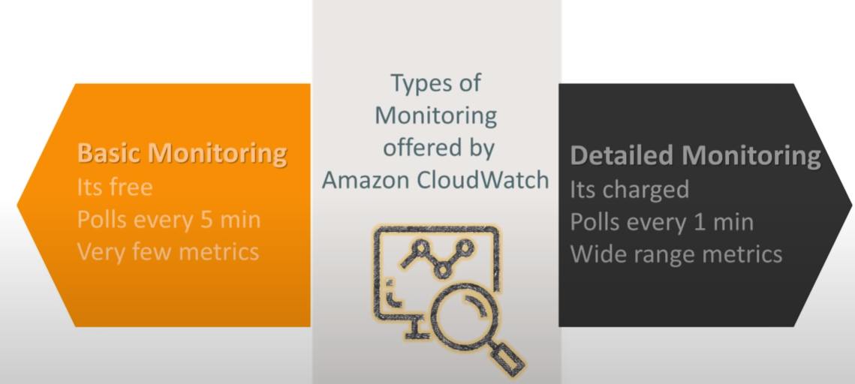

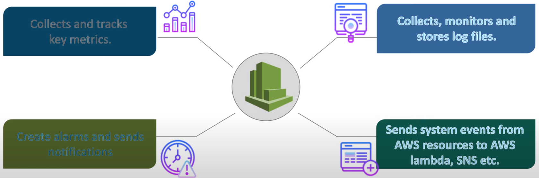

# Metrics

* Represent a datapoint with time series that is published.
  + Eg: CPU Utilization, Free RAM, Network Read Bytes, Disk IO
* Along with Standard metrics, users can create their own custom metrics.
* Cannot be deleted. If the metric doesn’t have a datapoint in last 15 months, then the metric gets deleted.
* Metrics Retention: If Datapoints time stamp with a Period < 60 seconds => 3 hours
  + with a Period = 60 seconds => 15 days
  + with a Period = 300 seconds => 63 days
  + with a period of 1 hour => 15 months (455 days)

# Statistics

* **Statistics:** For the metric values collected, following statistics will be available
  + Minimum
  + Maximum
  + Sum
  + Average
* **Alarm:** Alarm is some metric’s value over some period of time which needs some action to be taken. Examples for creating alarms. Each alarm will have some action that can be taken. Action could be sending email to admins to automatically reacting.

# How Amazon CloudWatch Works?

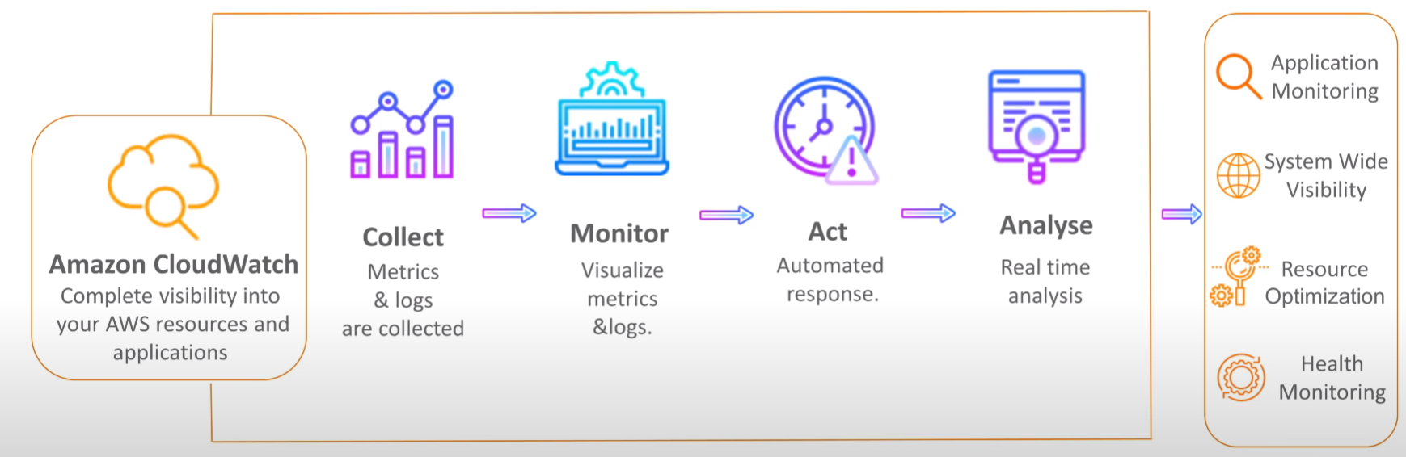

**Dashboards:** You should be Creating Dashboard of different Graphs/metrics for the resources that you are monitoring

**Logs:** A Centralized logs that can be stored from various services, monitored and queried

**Log Event:** Record of the log from some application/resource which is being monitored. Two Properties are to be present

* + Timestamp
  + Messages with UTF-8 Encoding

**Log Stream:** Sequence of log events from same source

**Log Groups:** Groups of log streams for one purpose (Could be one application or one business unit)

* Logs can be pushed from applications using Cloudwatch Logs api [Refer here](https://docs.aws.amazon.com/AmazonCloudWatchLogs/latest/APIReference/Welcome.html)
* Cloudwatch logs are used by the service Cloud Trail (Audit Trail)
* Create a Cloudwatch log group
* Create a VPC Flow log and send the logs to cloudwatch log group



# Events

* Change in AWS Environment.
* AWS Resources generate the events when their state changes
* For Event Types [Refer Here](https://docs.aws.amazon.com/AmazonCloudWatch/latest/events/EventTypes.html)

**Rules:**

* Rule is used to match incoming event and then route the event for processing to targets

**Target:**

* Target Processes events.
* Popular targets are
  + EC2 instance
  + AWS lambda
  + AWS SQS

# References

* Publish Custom Metrics

<https://aws.amazon.com/premiumsupport/knowledge-center/cloudwatch-custom-metrics/>

<https://docs.aws.amazon.com/AmazonCloudWatch/latest/monitoring/publishingMetrics.html>

* Cloud Watch Queries

<https://docs.aws.amazon.com/AmazonCloudWatch/latest/logs/AnalyzingLogData.html>